

<https://appraisalengine.com>

**The Rise of General Motors**

[**The Rise of General Motors**](https://appraisalengine.com/company/hyundai-history/)

**Monday, Aug 19, 2024.**

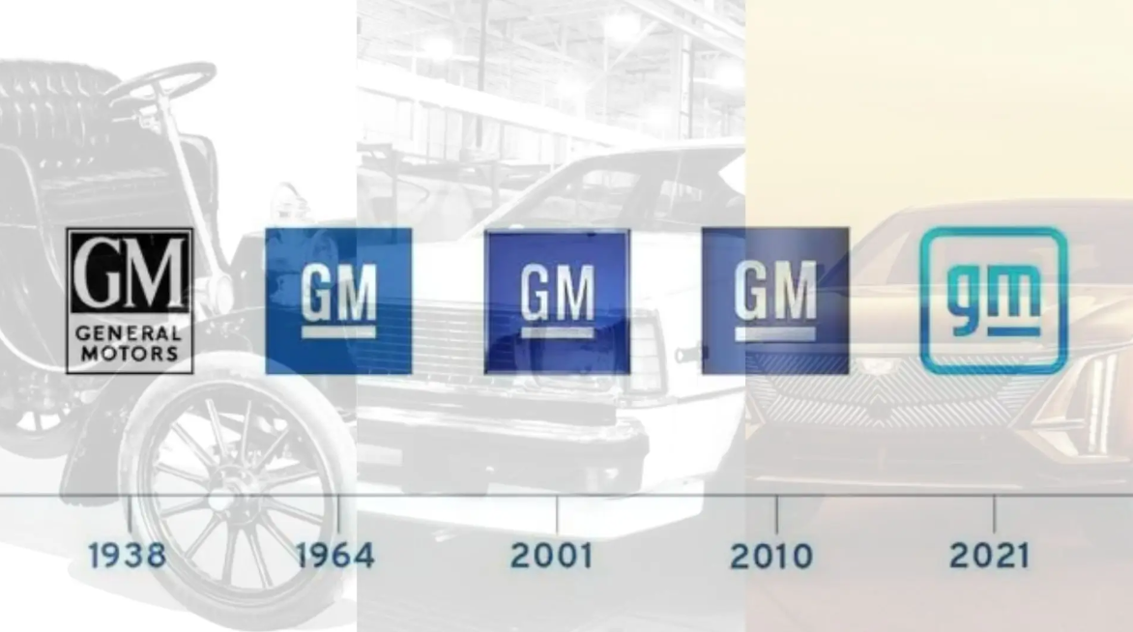

**Struggling to find a detailed and engaging account of General Motors' rich history?**

You're not alone. Many people are curious about how GM grew from its humble beginnings to become a global automotive titan.

This article aims to fill that gap, offering an in-depth look at GM’s journey, complete with expert insights, key innovations, and some surprising facts you won’t find on most websites.

**The Founding of General Motors: A Bold Vision for the Future**

**A Humble Beginning**

In 1908, William C. Durant founded General Motors in Flint, Michigan.

Durant, a visionary entrepreneur, aimed to create a company that would bring together multiple car manufacturers under one roof.

This was a bold move at a time when the automotive industry was still in its infancy.

GM started by acquiring Buick and rapidly expanded by purchasing other car companies, including Cadillac, Oldsmobile, and Pontiac.

**Strategic Acquisitions**

Durant’s strategy was clear: acquire and consolidate.

By the 1920s, GM had become a formidable force in the American automotive market.

Under the leadership of Alfred P. Sloan, who took over as president in 1923, GM introduced the concept of "a car for every purse and purpose."

This strategy allowed GM to offer a range of vehicles to suit different consumer needs and budgets.

"GM's strategy of diversification was key to its early success," notes automotive historian Dr. Robert Casey.

"It allowed the company to appeal to a broad spectrum of consumers, which was crucial in establishing its dominance."

**Innovations That Shaped the Automotive Industry**

**The Introduction of the Assembly Line**

One of GM’s most significant contributions to the automotive industry was the adoption and refinement of the assembly line.

Although Henry Ford is often credited with pioneering the assembly line, GM perfected the process, enabling the mass production of a variety of vehicles.

This innovation not only lowered production costs but also made cars more affordable for the average American.

**The Birth of Automatic Transmission**

In 1939, GM introduced the Hydra-Matic, the world’s first fully automatic transmission.

This groundbreaking innovation revolutionized the driving experience by making it easier and more comfortable.

The Hydra-Matic became a selling point for GM vehicles, and by the 1950s, it was a standard feature in many of their cars.

"GM's introduction of the automatic transmission was a game-changer," says automotive expert John Davis.

"It transformed driving from a skill-intensive activity to something that anyone could enjoy, regardless of their mechanical ability."

**Overcoming Challenges and Expanding Globally**

**The Post-War Boom**

After World War II, GM entered a period of unprecedented growth.

The company capitalized on the post-war economic boom, with Americans eager to buy new cars.

By 1955, GM had become the first American corporation to make over $1 billion in a single year.

The company’s success was driven by a combination of innovation, strategic marketing, and a strong economy.

**Global Expansion**

In the 1960s and 1970s, GM began to expand its operations globally.

The company established a strong presence in Europe, South America, and Asia.

This global expansion was part of GM’s strategy to diversify its markets and reduce its dependence on the U.S. economy.

"GM's global expansion was a critical move," notes industry analyst Jane Smith.

"It allowed the company to tap into emerging markets and sustain growth during periods of economic downturn in the U.S."

**Challenges and Resilience**

**The 2008 Financial Crisis**

Like many other companies, GM was hit hard by the 2008 financial crisis.

Facing bankruptcy, the company received a government bailout and underwent a significant restructuring.

GM emerged from the crisis leaner and more focused, shedding some of its less profitable brands, such as Pontiac and Saturn, to concentrate on core brands like Chevrolet, Cadillac, and GMC.

**The Rise of Electric Vehicles**

In recent years, GM has positioned itself as a leader in the electric vehicle (EV) market.

The company’s Chevrolet Bolt, introduced in 2016, was one of the first affordable, long-range electric cars.

GM has committed to an all-electric future, with plans to phase out gasoline and diesel-powered vehicles by 2035.

"GM's shift towards electric vehicles is a bold move," says EV specialist Mark Johnson.

"It shows the company’s commitment to sustainability and its ability to adapt to changing market demands."

**What You Probably Don't Know General Motors**

1. **GM's Role in the Apollo Program**GM played a crucial role in the U.S. space program by developing the guidance and navigation systems for the Apollo lunar missions.

2. **The Birth of OnStar**GM pioneered in-car safety technology with the introduction of OnStar in 1996, offering services like automatic crash response and vehicle tracking.

3. **The Electric Vehicle Experiment**Before the Chevy Bolt, GM experimented with electric vehicles in the 1990s with the EV1, a pioneering but short-lived electric car.

**Financial Performance and Strategic Vision**

General Motors remains a financial powerhouse.

In 2023, the company reported revenues of $160 billion, reflecting its strong market presence and strategic initiatives.

GM’s market valuation hovers around $70 billion, making it one of the most valuable automotive companies in the world.

"GM’s financial performance is a testament to its resilience and ability to adapt to changing market conditions," explains financial expert Sarah Lee.

**Driving Towards the Future**

General Motors’ journey from a small car company to a global automotive leader is nothing short of extraordinary.

The company’s ability to innovate, adapt, and overcome challenges has cemented its place in automotive history.

As GM continues to lead the charge into an all-electric future, it’s clear that this iconic brand is far from finished.

**What do you think the future holds for General Motors?**