

<https://appraisalengine.com>

**The Pinnacle of Luxury Car Brands in 2023**

**[The Pinnacle of Luxury Car Brands in 2023](https://appraisalengine.com/appraiser-blog/the-pinnacle-of-luxury-car-brands-in-2023)**

**Thursday, November 9th, 2023.**

Are you curious about the crème de la crème of luxury car brands in 2023? In today's automotive landscape, the line distinguishing luxury cars from their mainstream counterparts has never been more blurred. Whether you seek a more comfortable, opulent driving experience or simply desire a mainstream vehicle with enhanced interior quality and superior ride comfort, the choices are abundant. Let's delve into what the luxury automotive market has to offer.

Mainstream brands like Ford, Mazda, and Volkswagen have revamped their lineups, introducing a plethora of premium features and upgraded materials. In parallel, luxury marques like Mercedes-Benz and Lexus have distilled their time-honored quality and aesthetics into more compact, affordable packages.

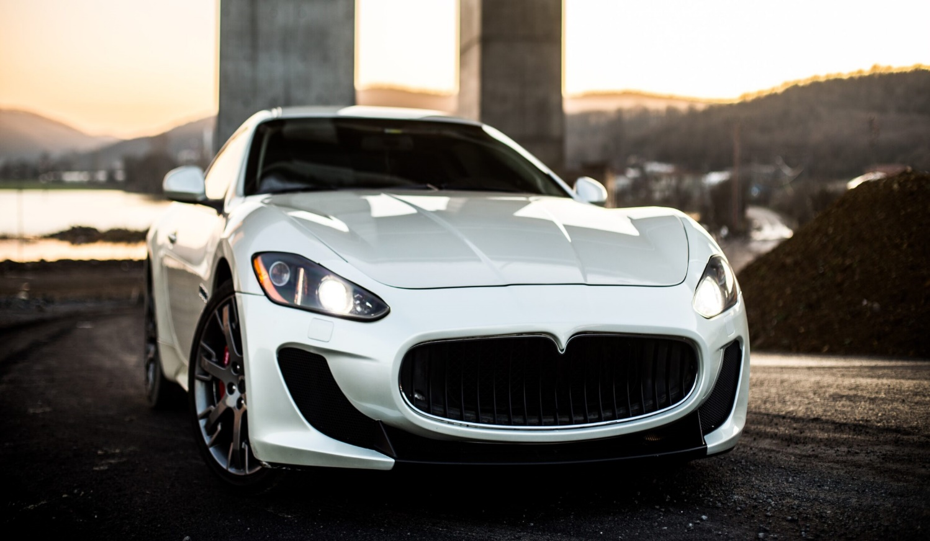

As these two categories increasingly overlap, the price divide is narrowing. Data indicates that the gap between the average prices of mainstream and luxury vehicles diminished by about 10% between the mid-2000s and mid-2010s. Although there remains a considerable discrepancy in the current average transaction prices, with luxury cars at around $78,000 and non-luxury models at approximately $43,000, automakers on both fronts are actively pursuing new customer segments.

**What Sets the Two Apart?**

With mainstream brands elevating their offerings and traditional luxury brands adapting to a broader market, sometimes it's difficult to tell them apart.

Luxury car brands offer a range of distinctive features, including full-grain and embossed leathers, special wood and metal trims, and interiors adorned with materials resembling suede or microfiber. Tech-savvy enhancements such as video-enhanced navigation and advanced safety systems, including hands-free driving capabilities, are typical in luxury cars. These vehicles prioritize plush rides, utilizing enhanced tires and suspensions, while extra layers of sound insulation ensure quieter cabins and more comfortable conversations. Premium audio systems, often equipped with 15 or more speakers, are a common luxury indulgence.

In addition, luxury cars are typically built as standalone models, sharing minimal hardware with less expensive mainstream counterparts. Some exceptions exist, as manufacturers like Ford, Toyota, and Volkswagen base their high-end luxury models on common platforms. For instance, the Lincoln Navigator SUV shares a platform with the Ford Expedition. Although some purists argue that genuine luxury cars should have exclusive foundations, these brands employ other methods to ensure their high-end vehicles stand out.

Another hallmark of luxury brands is the elevated level of dealership service, which may include courtesy loaner cars, waiting areas resembling upscale hotel lobbies, and concierge services that manage service appointments and repairs.

Perhaps the most intangible quality of a luxury car is its cachet. It's not solely features, trims, or technology that elevate a car to luxury status. Many luxury automakers boast a rich history, often rooted in motorsports excellence, and have earned a hard-earned reputation for consistent excellence. Keeping these principles in mind, here are the top luxury car brands for 2023

**1. Audi**

Audi offers a comprehensive lineup, from the compact A4 sedan to the Lamborghini-based R8 sports car. The brand is renowned for its sporty handling, sleek interior design, and top-grade materials, benefiting from its 100-year history and motorsports success.

**2. Aston Martin**

Known for elegant designs and powerful engines, Aston Martin's big, luxurious vehicles like the DBX SUV exude an air of exclusivity and comfort.

**3. Bentley**

Bentley, with its opulent vehicles, continues to be a storied luxury brand offering unparalleled appointments and customization options in its portfolio, including the Continental, Flying Spur, and Bentayga.

**4. BMW**

BMW's reputation for combining luxury interiors, athletic handling, and cutting-edge technology is evident across its extensive lineup, including the 2 Series and 7 Series sedan.

**5. Cadillac**

Cadillac, a symbol of American luxury, has made a resurgence, offering stylish performance sedans and the iconic Escalade SUV, known for its striking design and advanced tech.

**6. Genesis**

Genesis, a newcomer in the luxury segment, has quickly established itself as a legitimate alternative, boasting luxurious features, lush interiors, and Bentley-inspired styling.

**7. Jaguar**

This classic English brand, known for its powerful engines and decadent interiors, continues to captivate with stylish models like the F-Type sports car and F-Pace SUV.

**8. Land Rover**

Land Rover's Range Rover models, steeped in old-school English luxury, offer advanced four-wheel-drive systems, luxury-trimmed interiors, and stylish designs, making them an iconic choice.

**9. Lexus**

Lexus, a pioneer in automotive luxury, is synonymous with smooth rides, rich interiors, and exceptional dealer service. Known for its LS sedan, it remains a benchmark of comfort and refinement.

**10. Lincoln**

Alongside Cadillac, Lincoln was a midcentury American luxury icon. Its Navigator SUV, Nautilus, Aviator, and Corsair models feature lush interiors, advanced infotainment, and potent turbocharged power.

**11. Mercedes-Benz**

Mercedes-Benz, a synonymous name with luxury, offers a diverse range of vehicles, known for meticulous engineering, timeless elegance, and consistent refinement. The brand also leads in advanced driver assist systems and is expanding its lineup of electric vehicles.

**12. Porsche**

Recognized for performance, Porsche also provides high-quality leather, comfortable seats, and surprisingly smooth ride quality. The Cayenne SUV combines practicality with high-performance driving, and Porsche is venturing into electric vehicles with the Taycan.

**Honorable Mentions**

* Acura, Alfa Romeo, Bugatti, Ferrari, GMC, Infiniti, Maserati, Lamborghini, McLaren, Rolls-Royce, and Volvo all offer fine vehicles, but they may not consistently match the luxury focus of the top brands mentioned above.

**Regarding Electric Vehicles**

While many electric vehicles are priced similarly to luxury cars, few truly embody the luxury experience. Brands like Lucid and Polestar show promise, and Tesla deserves credit for its charging infrastructure, but some EVs lag behind in terms of refinement.

In 2023, the world of luxury cars offers an array of choices that cater to a variety of tastes, ensuring that the discerning driver finds a perfect match for their desire for opulence and performance.

For more news about the automotive market, take a look at this article: [The Best-Selling Cars in Each U.S. State for 2023](https://diminishedvalueofgeorgia.com/the-best-selling-cars-in-each-us-state/)